EX NO: 01 GENERATION OF SIGNALS
DATE:
AIM:
To generate various periodic and aperiodic signals such as circuit impulse, step, ramp, sinusoidal signal, cosine signal, exponential signal using MATLAB.
APPARATUS REQUIRED:
MATLAB software.
THEORY:
UNIT STEP SIGNAL: A continuous time unit step signal is denoted by u(t), mathematically it can be expressed as
u(t) = 1 for t>0 u(t) = 0 for t<0
UNIT RAMP SIGNAL: A continuous time ramp signal is denoted by r(t), mathematically it can be expressed as
r(t) = 1 for t=1 r(t) =0 for t<0
SINE WAVEFORM: A sinusoidal has the same shape as the graph of the sine function used in trigonometry. A discrete time sinusoidal waveform is denoted by
X[n] = A sin (n)
COSINE WAVEFORM: A cosine wave is a signal waveform with a shape identical to that of a sine wave, except each point on the cosine wave occurs exactly ¼ cycles earlier than the corresponding point on the sine wave.
IMPULSE SIGNAL: An impulse function is a special function that is often used by engineers to model certain events.
δ[n] = 1 at n=0 δ[n] = 0 at n≠0
EXPONENTIAL SIGNAL: The complex exponential is a complex valued signal that simultaneously encapsulates both a cosine signal and a sine signal by posting them on the real and imaginary components of complex signal. The continuous time complex exponential is defined as: Continuous time: s (t) =C e^{αt}

OUTPUT FOR UNIT IMPULSE SIGNAL:

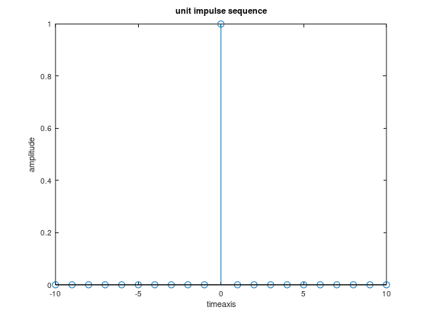

MATLAB CODE FOR UNIT IMPULSE SIGNAL:
clc;
clear all;
close all;
n=-10:1:10; x=[zeros(1,10),1,zeros(1,10)]; stem(n,x);
xlabel('timeaxis'); ylabel('amplitude');
title('unit impulse sequence’);

OUTPUT OF UNIT STEP SIGNAL:
CONTINUOUS SIGNAL
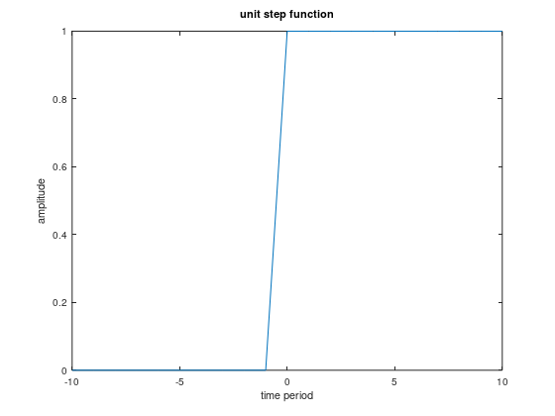
DISCRETE SIGNAL
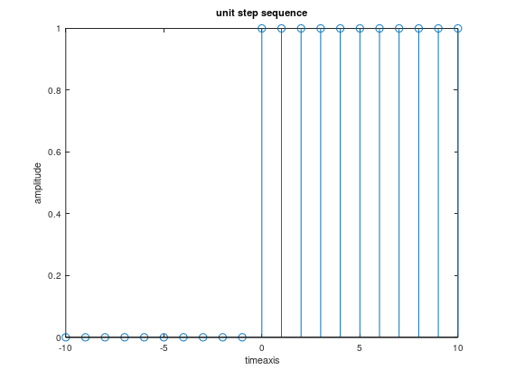

MATLAB CODE FOR UNIT STEP SIGNAL:
clc;
clear all;
close all;
n=-10:1:10; x=[zeros(1,10),ones(1,11)]; stem(n,x); xlabel('timeaxis'); ylabel('amplitude'); title('unit step sequence'); figure; plot(n,x); xlabel(‘time period’); ylabel(‘amplitude’); title(‘unit step function’);
OUTPUT FOR UNIT RAMP SIGNAL:
CONTINUOUS SIGNAL length=4
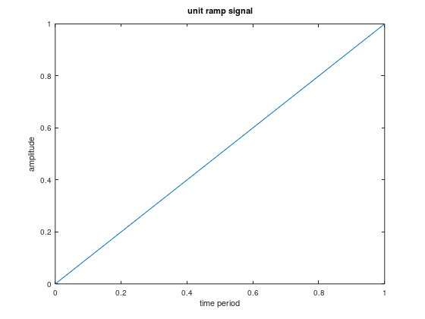

DISCRETE SIGNAL length=4
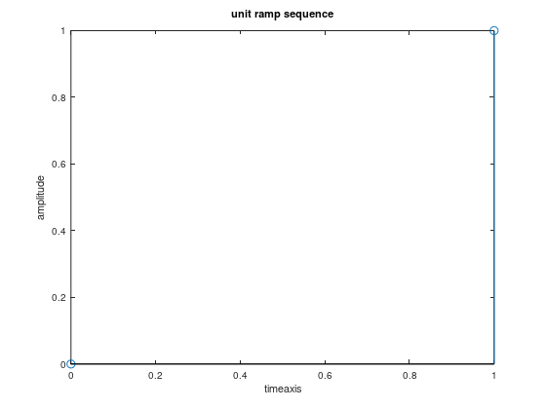

MATLAB CODE FOR UNIT RAMP SIGNAL:

clc;
clear all;
close all; l=input(‘length=’);
n=0:1:1;
x=[0,1:1];
stem(n,x); xlabel('timeaxis'); ylabel('amplitude'); title('unit ramp sequence’);
figure;
plot(n.x);
xlabel(‘time period’); ylabel(‘amplitude’); title(‘unit ramp signal’);

OUTPUT FOR INCREASING EXPONENTIAL FUNCTION:
CONTINUOUS SIGNAL length=4
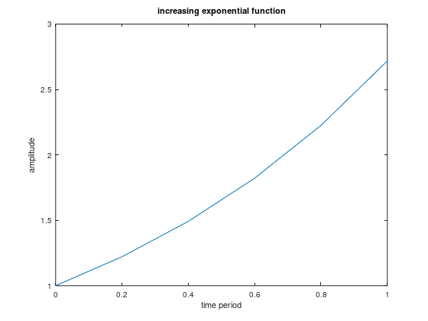
DISCRETE SIGNAL length=8
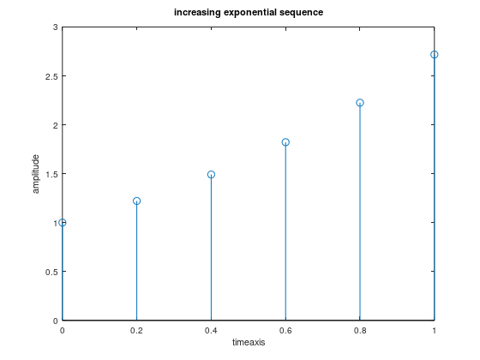

MATLAB CODE FOR INCREASING EXPONENTIAL SIGNAL:

clc;
clear all;
close all;
l=input(‘length=’);
n=0:0.2:1;
stem(n,exp(n));
xlabel('timeaxis');
ylabel('amplitude');
title(‘increasing exponential sequence’);
figure;
plot(n,exp(n));
xlabel(‘time period’); ylabel(‘amplitude’);
title(‘increasing exponential function’);

OUTPUT FOR DECREASING EXPONENTIAL SIGNAL:
CONTINUOUS SIGNAL length=4
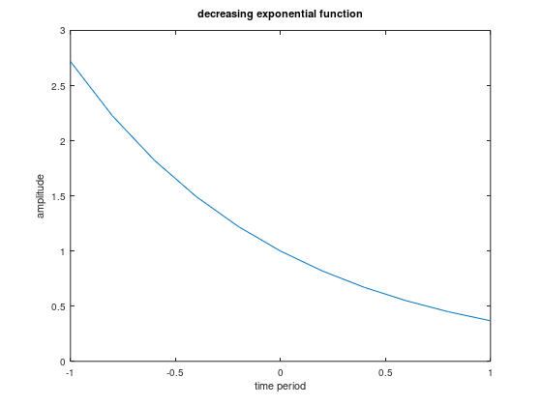
DISCRETE SIGNAL length=4
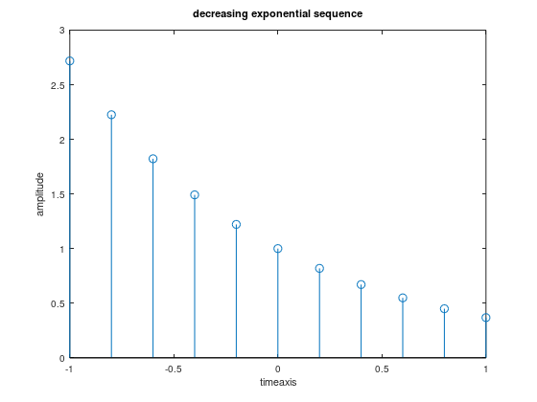

MATLAB CODE FOR DECREASING EXPONENTIAL SIGNAL:
clc;
clear all;
close all; l=input(‘length=’); n=-1:0.2:1; stem(n,exp(-n)); xlabel('timeaxis'); ylabel('amplitude');
title(‘decreasing exponential sequence’);
figure; plot(n,exp(-n)); xlabel(‘time period’); ylabel(‘amplitude’);
title(‘decreasing exponential function’);

OUTPUT FOR SINUSOIDAL SIGNAL:
CONTINUOUS SIGNAL length=10
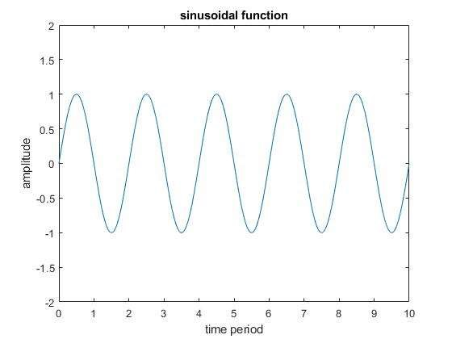
DISCRETE SIGNAL length=10
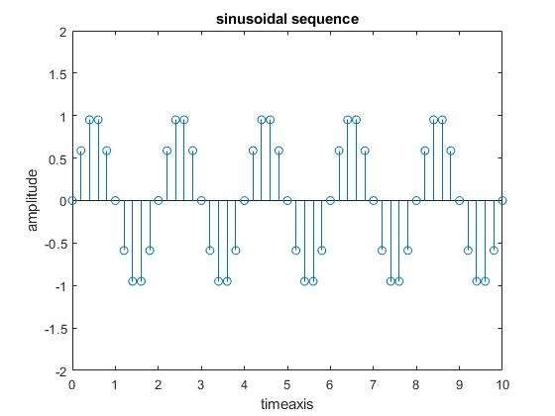

MATLAB CODE FOR SINUSOIDAL SIGNAL:
clc;
clear all;
close all; l=input(‘length=’); n=0:0.2:1; stem(n,sin(pi*n)); xlabel('timeaxis'); ylabel('amplitude'); title(‘sinusoidal sequence’); figure;
plot(n,sin(pi*n)); xlabel('time period'); ylabel('amplitude');
title(‘sinusoidal function’);

OUTPUT FOR COSINE SIGNAL:
CONTINUOUS SIGNAL length=10
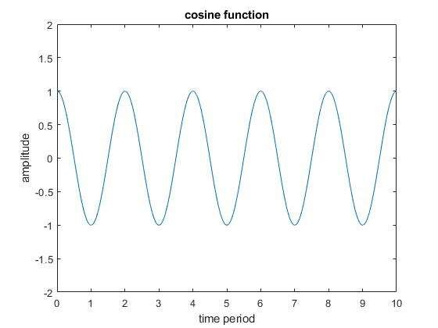
DISCRETE SIGNAL length=10
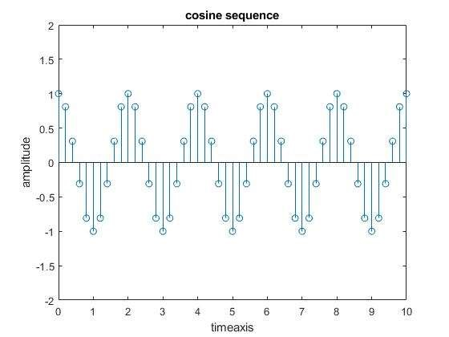
MATLAB CODE FOR COSINE SIGNAL:

clc;
clear all;
close all; l=input(‘length=’); n=0:0.1:1; stem(n,cos(pi*n)); xlabel('timeaxis'); ylabel('amplitude'); title(‘cosine sequence’); figure; plot(n,cos(pi*n)); xlabel('time period'); ylabel('amplitude');
title(‘cosine function’);

OUTPUT FOR PARABOLIC SIGNAL:
CONTINUOUS SIGNAL length=10
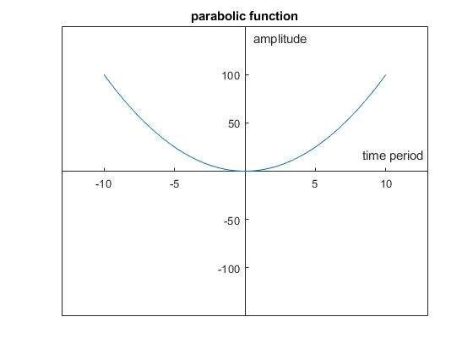
DISCRETE SIGNAL length=10
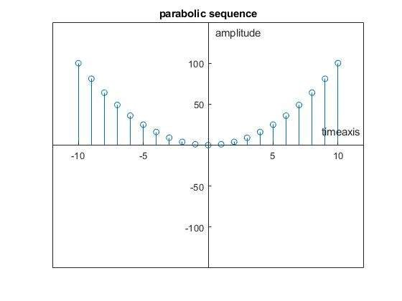

MATLAB CODE FOR PARABOLIC SIGNAL:

clc; clear all; close all; l=input(‘length=’);
n=-1:0.2:1;
x=n.^2;
stem(n,x); xlabel('timeaxis'); ylabel('amplitude'); title('parabolic sequence'); figure;
plot(n,x);
xlabel('time period'); ylabel('amplitude'); title('parabolic function');

INFERENCE:

CONTENTS | MARKS AWARDED | MARKS OBTAINED
PREPARATION | 40
OBSERVATION | 30
RECORD | 20
VIVA VOCE | 10
TOTAL | 100

RESULT:
The various periodic and aperiodic signals are verified and generated using
MATLAB.

EX NO: 02 LINEAR CONVOLUTION
DATE:
AIM:
To calculate and plot linear convolution of two signals by using MATLAB software.
APPARATUS REQUIRED:
MATLAB Software.
THEORY:
LINEAR CONVOLUTION:
Linear convolution takes two function of an independent variable,which will call time and convolves them using the convolution sum formula. It is the basic operation to calculate the output for any linear time invarient system given its input and its impulse response.

OUTPUT :
The convolution result is:
1 1 3 5 2 8

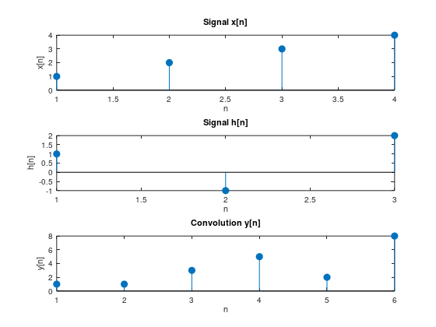

CODING FOR LINEAR CONVOLUTION:
x = [1, 2, 3, 4];
h = [1, -1, 2];
y = conv(x, h);
disp('The convolution result is:');
disp(y);
figure;
subplot(3, 1, 1);
stem(x, 'filled');
title('Signal x[n]');
xlabel('n');
ylabel('x[n]');

subplot(3, 1, 2);
stem(h, 'filled');
title('Signal h[n]');
xlabel('n');
ylabel('h[n]');

subplot(3, 1, 3);
stem(y, 'filled');
title('Convolution y[n]');
xlabel('n');
ylabel('y[n]');

INFERENCE:

CONTENTS | MARKS AWARDED | MARKS OBTAINED
PREPARATION | 40
OBSERVATION | 30
RECORD | 20
VIVA VOCE | 10
TOTAL | 100

RESULT:
Thus, the program for linear convolution was executed and the output is verified using MATLAB.

EX NO:03 CIRCULAR CONVOLUTION
DATE:
AIM:
To calculate and plot circular convolution of two signals using MATLAB software.
SOFTWARE REQUIRED:
MATLAB software.

THEORY:
CIRCULAR CONVOLUTION:
The circular convolution, also known as cyclic convolution, of two aperiodic functions (i.e. Schwartz functions) occurs when one of them is convolved in the normal way with a periodic summation of the other function. That situation arises in the context of the circular convolution theorem. The identical operation can also be expressed in terms of the periodic summations of both functions, if the infinite integration interval is reduced to just one period. That situation arises in the context of the discrete-time Fourier transform (DTFT) and is also called periodic convolution

OUTPUT FOR CIRCULAR CONVOLUTION USING MATRIX METHOD:

Circular Convolution Result:
8 8 12 12

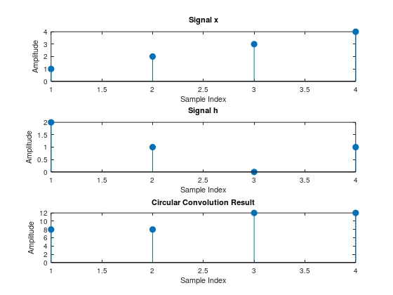

CODING FOR CIRCULAR CONVOLUTION:
x = [1, 2, 3, 4];
h = [2, 1, 0, 1];
N = length(x);
if length(h) < N
h = [h, zeros(1, N - length(h))];
elseif length(h) > N
x = [x, zeros(1, length(h) - N)];
N = length(x);
end
X = fft(x);
H = fft(h);
Y = X .* H;
y = ifft(Y);
disp('Circular Convolution Result:');
disp(y);
figure;
subplot(3,1,1);
stem(x, 'filled');
title('Signal x');
xlabel('Sample Index');
ylabel('Amplitude');
subplot(3,1,2);
stem(h, 'filled');
title('Signal h');
xlabel('Sample Index');
ylabel('Amplitude');
subplot(3,1,3);
stem(y, 'filled');
title('Circular Convolution Result');
xlabel('Sample Index');
ylabel('Amplitude');

INFERENCE:

CONTENTS | MARKS AWARDED | MARKS OBTAINED
PREPARATION | 40
OBSERVATION | 30
RECORD | 20
VIVA VOCE | 10
TOTAL | 100

RESULT:
Thus, the program for circular convolution was executed and the output is verified using MATLAB.

EX NO: 04 SAMPLING AND EFFECT OF ALAISING

DATE :
AIM:
To generate and plot the sampling of sinusoidal signal by using MATLAB.
SOFTWARE REQUIRED:
MATLAB software.

THEORY:
SAMPLING THEOREM:
A continuous time signal can be represented in its samples and can be recovered back when sampling frequency f_{s} is greater than or equal to the twice the highest frequency component of message signal
f _{s} ≥ 2f_{m}
ALAISING:
In signal processing, aliasing is an effect that cause different signals to become indistinguishable (or aliases of one another) when sampled. It also refers to the distortion or artifact that results when the signal reconstructed from samples is different from the original continuous signal.

OUTPUT:
FIGURE 1

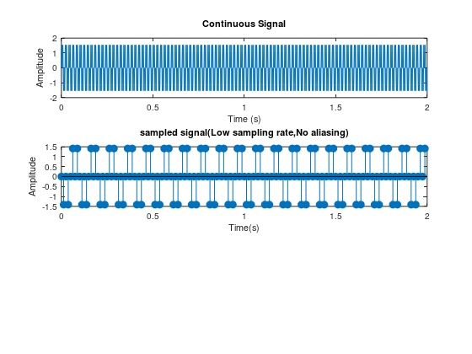

FIGURE 2

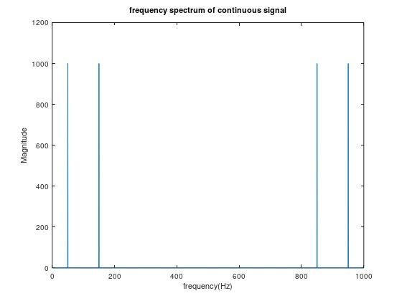

CODING FOR SAMPLING AND ALAISING:
Fs_continuous = 1000;
T = 1 / Fs_continuous;
L = 2;
t_continuous = 0:T:(L-T);
f1 = 50;
f2 = 150;
x_continuous = sin(2 * pi * f1 * t_continuous) + sin(2 * pi * f2 * t_continuous);
figure;
subplot(3, 1, 1);
plot(t_continuous, x_continuous);
title('Continuous Signal');
xlabel('Time (s)');
ylabel('Amplitude');
Fs_low = 80;
Fs_high = 300;
t_low = 0:1/Fs_low:(L-1/Fs_low);
t_high = 0:1/Fs_high:(L-1/Fs_high);
x_low = sin(2 * pi * f1 * t_low) + sin(2 * pi * f2 * t_low);
x_high=sin(2 * pi* f1 * t_high) + sin(2 * pi * f2 * t_high);
subplot(3,1,2);
stem(t_low,x_low,'filled');
title('sampled signal(Low sampling rate,No aliasing)');
xlabel('Time(s)');
ylabel('Amplitude');
N=length(t_continuous);
Y_cont=fft(x_continuous);
f_cont=(0:N-1)*(Fs_continuous/N);
figure;
plot(f_cont,abs(Y_cont));
title('frequency spectrum of continuous signal');
xlabel('frequency(Hz)');
ylabel('Magnitude');
N_low=length(t_low);
Y_low=fft(x_low,N_low);
f_low=(0:N_low-1)*(Fs_low/N_low);
figure;
plot(f_low,abs(Y_low));
title('Frequency spectrum of low sampling rate signal');
xlabel('Frequency(Hz)');
FIGURE 3
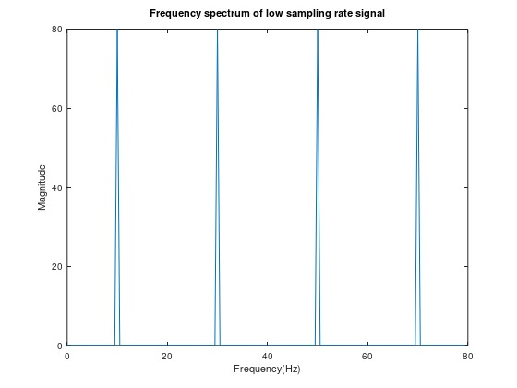

FIGURE 4

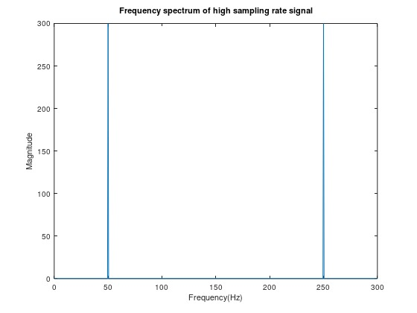

ylabel('Magnitude');
N_high=length(t_high);
Y_high=fft(x_high,N_high);
f_high=(0:N_high-1)*(Fs_high/N_high);
figure;
plot(f_high,abs(Y_high));
title('Frequency spectrum of high sampling rate signal');
xlabel('Frequency(Hz)');
ylabel('Magnitude');OUTPUT:

INFERENCE:

CONTENTS | MARKS AWARDED | MARKS OBTAINED
PREPARATION | 40
OBSERVATION | 30
RECORD | 20
VIVA VOCE | 10
TOTAL | 100

RESULT:
Thus, the program for sampling and aliasing of sinusoidal signal was executed and the output was verified using MATLAB.

EX NO: 05 SPECTRUM ANALYSIS USING FFT OF SIGNAL
DATE:
AIM:
To perform the spectrum of signal using FFT and plot the signal using
MATLAB.

APPARATUS REQUIRED:
MATLAB Software
THEORY:
The Fast Fourier Transform is an algorithm optimization of the DFT—Discrete
Fourier Transform. The “discrete” part just means that it’s an adaptation of the Fourier Transform, a continuous process for the analog world, to make it suitable for the sampled digital world. The FFT or Fast Fourier Transform spectrum analyzer is now a form of RF spectrum analyzer that is being used increasingly to improve performance reduce costs.
As the name suggests the FFT spectrum analyzer is an item of RF test equipment that uses Fourier analysis and digital signal processing techniques to provide spectrum analysis. Using Fourier analysis any waveform in the time domain can be represented by the weighted sum of sine and cosine signals. Using this concept, the FFT spectrum analyzer samples the input signal. It then computes the magnitude of its sine and cosine components of the overall signal, and finally it displays the spectrum of the signal.

OUTPUT:

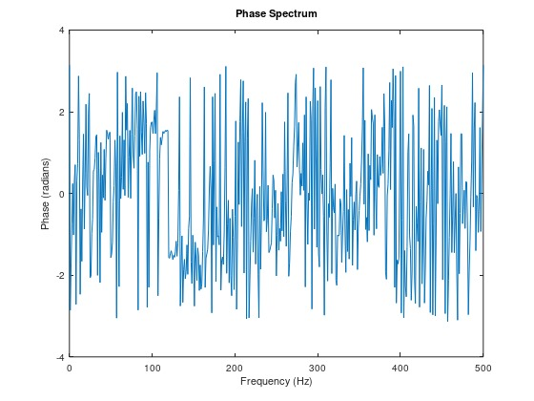
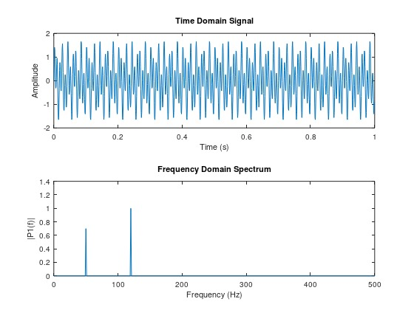

CODING:
Fs = 1000;
T = 1 / Fs;
L = 1000;
t = (0:L-1) * T;
f1 = 50;
f2 = 120;
x = 0.7 * sin(2 * pi * f1 * t) + sin(2 * pi * f2 * t);
X = fft(x);
P2 = abs(X / L);
P1 = P2(1:L/2+1);
P1(2:end-1) = 2 * P1(2:end-1);
f = Fs * (0:(L/2)) / L;
figure;
subplot(2, 1, 1);
plot(t, x);
title('Time Domain Signal');
xlabel('Time (s)');
ylabel('Amplitude');
subplot(2, 1, 2);
plot(f, P1);
title('Frequency Domain Spectrum');
xlabel('Frequency (Hz)');
ylabel('|P1(f)|');
figure;
phase = angle(X(1:L/2+1));
plot(f, phase);
title('Phase Spectrum');
xlabel('Frequency (Hz)');
ylabel('Phase (radians)');

INFERENCE:

CONTENTS | MARKS AWARDED | MARKS OBTAINED
PREPARATION | 40
OBSERVATION | 30
RECORD | 20
VIVA VOCE | 10
TOTAL | 100

RESULT:
Thus the program for spectrum analysis of FFT signal using MATLAB software is performed and verified.

EX NO: 06 CALCULATION OF FFT OF A SIGNAL
DATE:
AIM:
To calculate the FFT of a signal by using MATLAB software.
APPARATUS REQUIRED:
MATLAB Software.
THEORY:
FAST FOURIER TRANSFORM:
A fast fourier transform(FFT) is an algorithm that calculates the discrete fourier transform (DFT) of some sequence. The DFT is a tool to convert specific types of function into other types of representations. Another way to explain DFT is that it transforms a structure of a cycle of a waveform into sine components.

OUTPUT:

Input Signal:
1 2 3 4
FFT of the Signal:
10 + 0i -2 + 2i -2 + 0i -2 - 2i

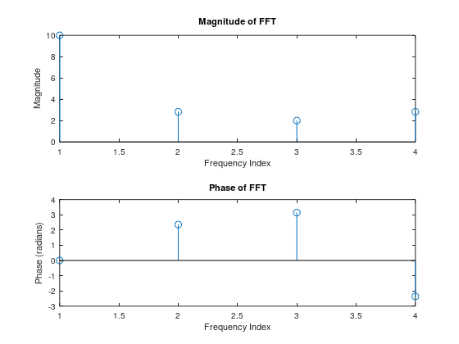

CODING FOR CALCULATION OF FFT :
x = [1, 2, 3, 4];
X = fft(x);
disp('Input Signal:');
disp(x);
disp('FFT of the Signal:');
disp(X);
figure;
subplot(2, 1, 1);
stem(abs(X));
title('Magnitude of FFT');
xlabel('Frequency Index');
ylabel('Magnitude');
subplot(2, 1, 2);
stem(angle(X));
title('Phase of FFT');
xlabel('Frequency Index');
ylabel('Phase (radians)');

INFERENCE:

CONTENTS | MARKS AWARDED | MARKS OBTAINED
PREPARATION | 40
OBSERVATION | 30
RECORD | 20
VIVA VOCE | 10
TOTAL | 100

RESULT:
Thus, the program for calculation of FFT of a signal is executed and the output is verified using MATLAB.

EX.NO:07 DESIGN OF FIR FILTER USING WINDOWING
DATE: TECHNIQUE & FREQUENCY SAMPLING METHOD
AIM:
To design the Low pass and high pass filters using windowing technique, using MATLAB software.
APPARATUS REQUIRED:
MATLAB Software
THEORY:
FIR FILTER:
In signal processing, the FIR(Finite Impulse Response) is a filter whose impulse response is of finite duration because it settles to zero in finite time.
WINDOWING TECHNIQUE:
- HANNING WINDOW:
This is known as a cosine taper. Its starts at 0, rises to 1 in the middle of the period and then goes smoothly back down to 0 at the end.
w₁(t)=0.5-0.5*cos(2pt/T)
If x(t) is the data (presumed to have zero mean value), then the windowed version of the data, y(t), is computed as follows: Y₁(t)=x(t)* w₁(t)

- HAMMING WINDOW:
This modified cosine taper starts at 0.08, raises to to 1 in the middle of the period and then goes smoothly back down to 0.08 at the end.
w₂(t)=0.54-0.46*cos(2pt/T)
y₂(t)=x(t)* w₂(t)

OUTPUT:

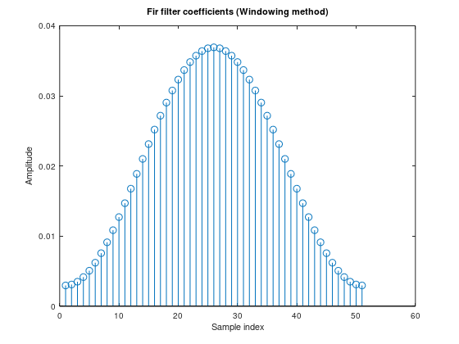

- BLACKMAN WINDOW:

This modified cosine taper uses two cosines.
W₃(t)=0.42-0.5*cos(2pt/T)+0.08* cos(4pt/T)
Y₃(t)=x(t)* w₃(t)
- KAISER WINDOW:
This tapering function has an adjustable parameter which can vary from 0 to ∞, but the range 3≤b≤10 is typical. When b=0, the Kaiser windows becomes a rectangular window(no tapering). As b rises, tapering increases and the main lobe width increases and sideband attenuation increases

OUTPUT

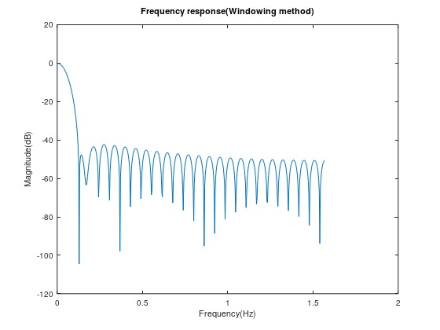

CODING:

N=51;
fc=0.25;
n=(0:(N-1))-(N-1)/2;
h_ideal=sin(2*pi*fc*n)./(pi*n);
h_ideal((N-1)/2+1)=2*fc;
window=hamming(N);
h_windowed=h_ideal.*window;
h_windowed=h_windowed/sum(h_windowed);
figure;
stem(h_windowed);
title('Fir filter coefficients (Windowing method)');
xlabel('Sample index');
ylabel('Amplitude');
[Hz,f]=freqz(h_windowed,1,512,'half');
figure;
plot(f*0.5,20*log10(abs(Hz)));
title('Frequency response(Windowing method)');
xlabel('Frequency(Hz)');
ylabel('Magnitude(dB)');

INFERENCE:

CONTENTS | MARKS AWARDED | MARKS OBTAINED
PREPARATION | 40
OBSERVATION | 30
RECORD | 20
VIVA VOCE | 10
TOTAL | 100

RESULT:
Thus the program for FIR filter using Windowing technique is performed and verified.

EX NO: 08 DESIGN OF IIR FILTER USING BILINEAR
DATE: TRANSFORMATION METHOD
AIM:
To design the low pass IIR filter using bilinear transformation method and to plot the magnitude response characteristics using MATLAB software.
APPARATUS REQUIRED:
MATLAB Software
THEORY:
The bilinear transform (also known as Tustin's method) is used in digital signal processing and discrete-time control theory to transform continuous-time system representations to discrete-time and vice versa. The bilinear transform is a special case of a conformal mapping (namely, a Mobius transformation), often used to convert a transfer function of a linear, time-invariant (LTI) filter in the continuous-time domain (often called an analog filter) to a transfer function of a linear, shift-invariant filter in the discrete-time domain (often called a digital filter although there are analog filters constructed with switched capacitors that are discrete-time filters). It maps positions on the axis, , in the s-plane to the unit circle, , in the z-plane. Other bilinear transforms can be used to warp the frequency response of any discrete-time linear system (for example to approximate the non-linear frequency resolution of the human auditory system) and are implementable in the discrete domain by replacing a system's unit delays with first order all-pass filters.

OUTPUT :
Digital filter coefficients:
b =
1
a =
Columns 1 through 6:

1.0000e+00 -1.6087e+00 9.6398e-01 -2.5496e-01 -3.2608e-01 2.4941e-01

Columns 7 through 9:

-4.4653e-02 -1.7347e-18 9.9228e-03

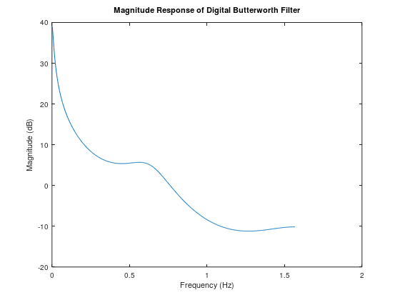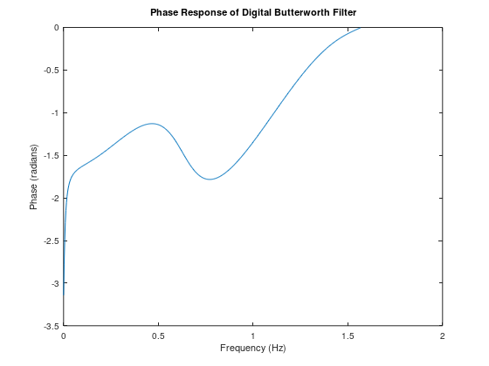
CODING:

N = 4;
Wp = 0.2;
Fs = 1;
theta = (2*(1:N) + N - 1) * pi / (2 * N);
poles = exp(1j * theta);
poles = (2 * Fs + poles) ./ (2 * Fs - poles);
function [b, a] = compute_tf_coeffs(poles, k)
a = 1;
for i = 1:length(poles)
a = conv(a, [1 -real(poles(i)) -imag(poles(i))]);
end
b = k;
end
[bz, az] = compute_tf_coeffs(poles, 1);
disp('Digital filter coefficients:');
disp('b = ');
disp(bz);
disp('a = ');
disp(az);
[Hz, f] = freqz(bz, az, 512, 'half');
f = f * 0.5;
figure;
plot(f, 20*log10(abs(Hz)));
title('Magnitude Response of Digital Butterworth Filter');
xlabel('Frequency (Hz)');
ylabel('Magnitude (dB)');
figure;
plot(f, angle(Hz));
title('Phase Response of Digital Butterworth Filter');
xlabel('Frequency (Hz)');
ylabel('Phase (radians)');

INFERENCE:

CONTENTS | MARKS AWARDED | MARKS OBTAINED
PREPARATION | 40
OBSERVATION | 30
RECORD | 20
VIVA VOCE | 10
TOTAL | 100

RESULT:
Thus the IIR filter has been designed by using bilinear transformation technique and the output has been verified.

EX NO: 09 DESIGN OF IIR FILTER USING IMPULSE
DATE: INVARIANT METHOD

AIM:
To design the low pass IIR filter using impulse invariant method and to plot the magnitude response characteristics using MATLAB software.
APPARATUS REQUIRED:
MATLAB Software

THEORY:
Impulse response (IIR) is a property applying to any linear time invariant system. Common examples of linear time invariant systems are most electronic and digital filters. Systems with this property are known as IIR systems or IIR filters and are distinguished by having an impulse response which doesn’t becomes exactly zero past a certain point, but continuous indefinitely. This is contrast to FIR in which the impulse response h(t) thus becomes exactly zero at times t>T for some finite T, thus being of finite duration. The primary advantage of IIR filter over FIR filter is that typically meet a given set of specifications with a much lower filter order than a corresponding FIR filter.

OUTPUT :
Digital filter coefficients:
b = 1
a =
Columns 1 through 6:
1.0000e+00 -1.6087e+00 9.6398e-01 -2.5496e-01 -3.2608e-01 2.4941e-01
Columns 7 through 9:
-4.4653e-02 -1.7347e-18 9.9228e-03

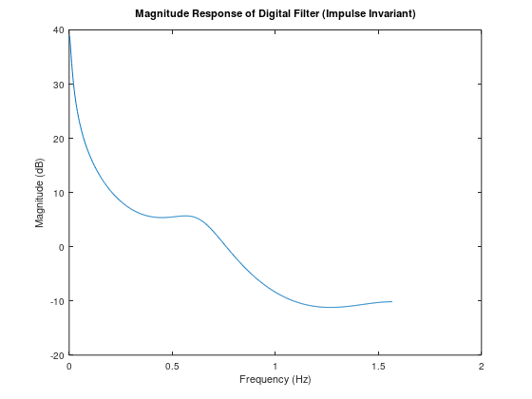

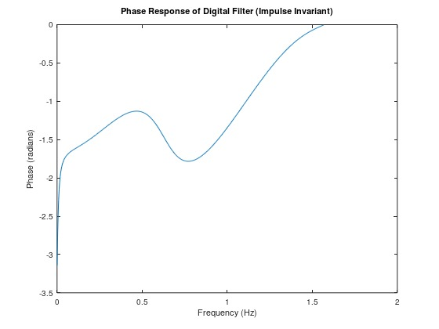

CODING:

N = 4;
Wp = 0.2;
Fs = 1;
theta = (2*(1:N) + N - 1) * pi / (2 * N);
poles = exp(1j * theta);
poles = (2 * Fs + poles) ./ (2 * Fs - poles);
function [b, a] = compute_tf_coeffs(poles, k)
a = 1;
for i = 1:length(poles)
a = conv(a, [1 -real(poles(i)) -imag(poles(i))]);
end
b = k;
end
[bz, az] = compute_tf_coeffs(poles, 1);
disp('Digital filter coefficients:');
disp('b = ');
disp(bz);
disp('a = ');
disp(az);
[Hz, f] = freqz(bz, az, 512, 'half');
f = f * 0.5;
figure;
plot(f, 20*log10(abs(Hz)));
title('Magnitude Response of Digital Butterworth Filter');
xlabel('Frequency (Hz)');
ylabel('Magnitude (dB)');
figure;
plot(f, angle(Hz));
title('Phase Response of Digital Butterworth Filter');
xlabel('Frequency (Hz)');
ylabel('Phase (radians)');

INFERENCE:

CONTENTS | MARKS AWARDED | MARKS OBTAINED
PREPARATION | 40
OBSERVATION | 30
RECORD | 20
VIVA VOCE | 10
TOTAL | 100

RESULT:
Thus the IIR filter has been designed by using impulse invariant technique and the output has been verified.

EX NO: 10 VERIFICATION OF BIBO STABILITY OF
DATE: A SYSTEM
AIM:
To determine the BIBO (Bounded Input Bounded Output) stability of a discrete-time system by analyzing its poles using MATLAB software.
APPARATUS REQUIRED:
MATLAB Software
THEORY:
BIBO stability is a concept in digital signal processing and control theory that ensures a system's output remains bounded for any bounded input. For a discrete-time system to be BIBO stable, all its poles must lie within the unit circle in the z-plane. This condition ensures that the system’s response does not grow unboundedly over time. By locating the system's poles and verifying they all lie within the unit circle, we can confirm the stability of the system.

OUTPUT :

Poles of the system:
0.9000
0.9000
Zeros of the system:
1
The system is BIBO stable.

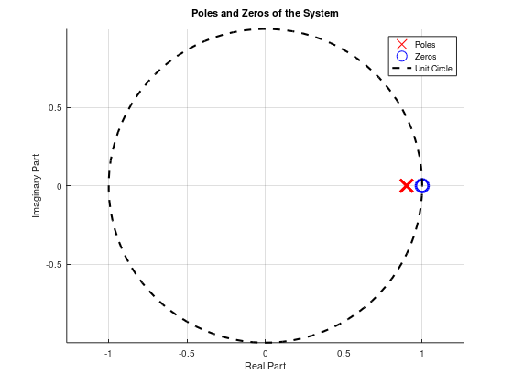

CODING:

b = [0.5, -0.5];
a = [1, -1.8, 0.81];
poles = roots(a);
zeros = roots(b);

disp('Poles of the system:');
disp(poles);
disp('Zeros of the system:');
disp(zeros);
is_stable = all(abs(poles) < 1);
if is_stable
disp('The system is BIBO stable.');
else
disp('The system is NOT BIBO stable.');
end
figure;
hold on;
plot(real(poles), imag(poles), 'rx', 'MarkerSize', 10, 'LineWidth', 2);
plot(real(zeros), imag(zeros), 'bo', 'MarkerSize', 10, 'LineWidth', 2);
theta = linspace(0, 2*pi, 100);
x = cos(theta);
y = sin(theta);
plot(x, y, 'k--', 'LineWidth', 1.5);

title('Poles and Zeros of the System');
xlabel('Real Part');
ylabel('Imaginary Part');
axis equal;
grid on;
legend('Poles', 'Zeros', 'Unit Circle');
hold off;

INFERENCE:

CONTENTS | MARKS AWARDED | MARKS OBTAINED
PREPARATION | 40
OBSERVATION | 30
RECORD | 20
VIVA VOCE | 10
TOTAL | 100

RESULT:
Thus the poles of the system have been analyzed, and it has been determined whether the system is BIBO stable based on their locations within the unit circle in the z-plane.

